***Database Management System***

***Mini – Project***

|  |  |  |
| --- | --- | --- |
| *Name: Hari Om Swarup S A* | *SRN: PES2UG20CS132* | *Date: 24th October 2022* |

*Project Title: Cloud Inventory Management System*

*Synopsis:*

*As the world is shifting towards digitalizing and automating work flow, users prefer to work in the cloud. Hence, bringing users to rent virtual machine instances in the cloud with customisable hardware and also keep their data in cloud storage buckets which is stored in data warehouse.*

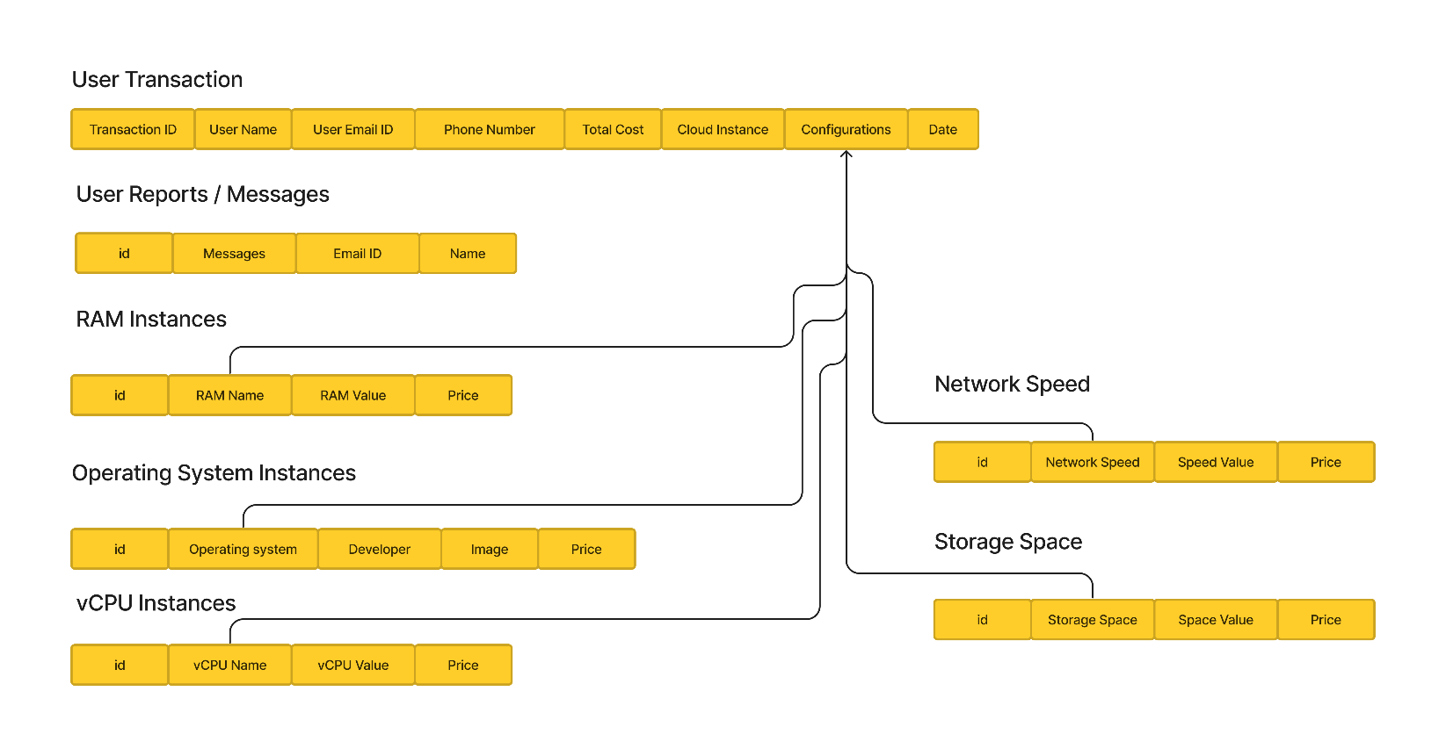*Relational Mapping:*

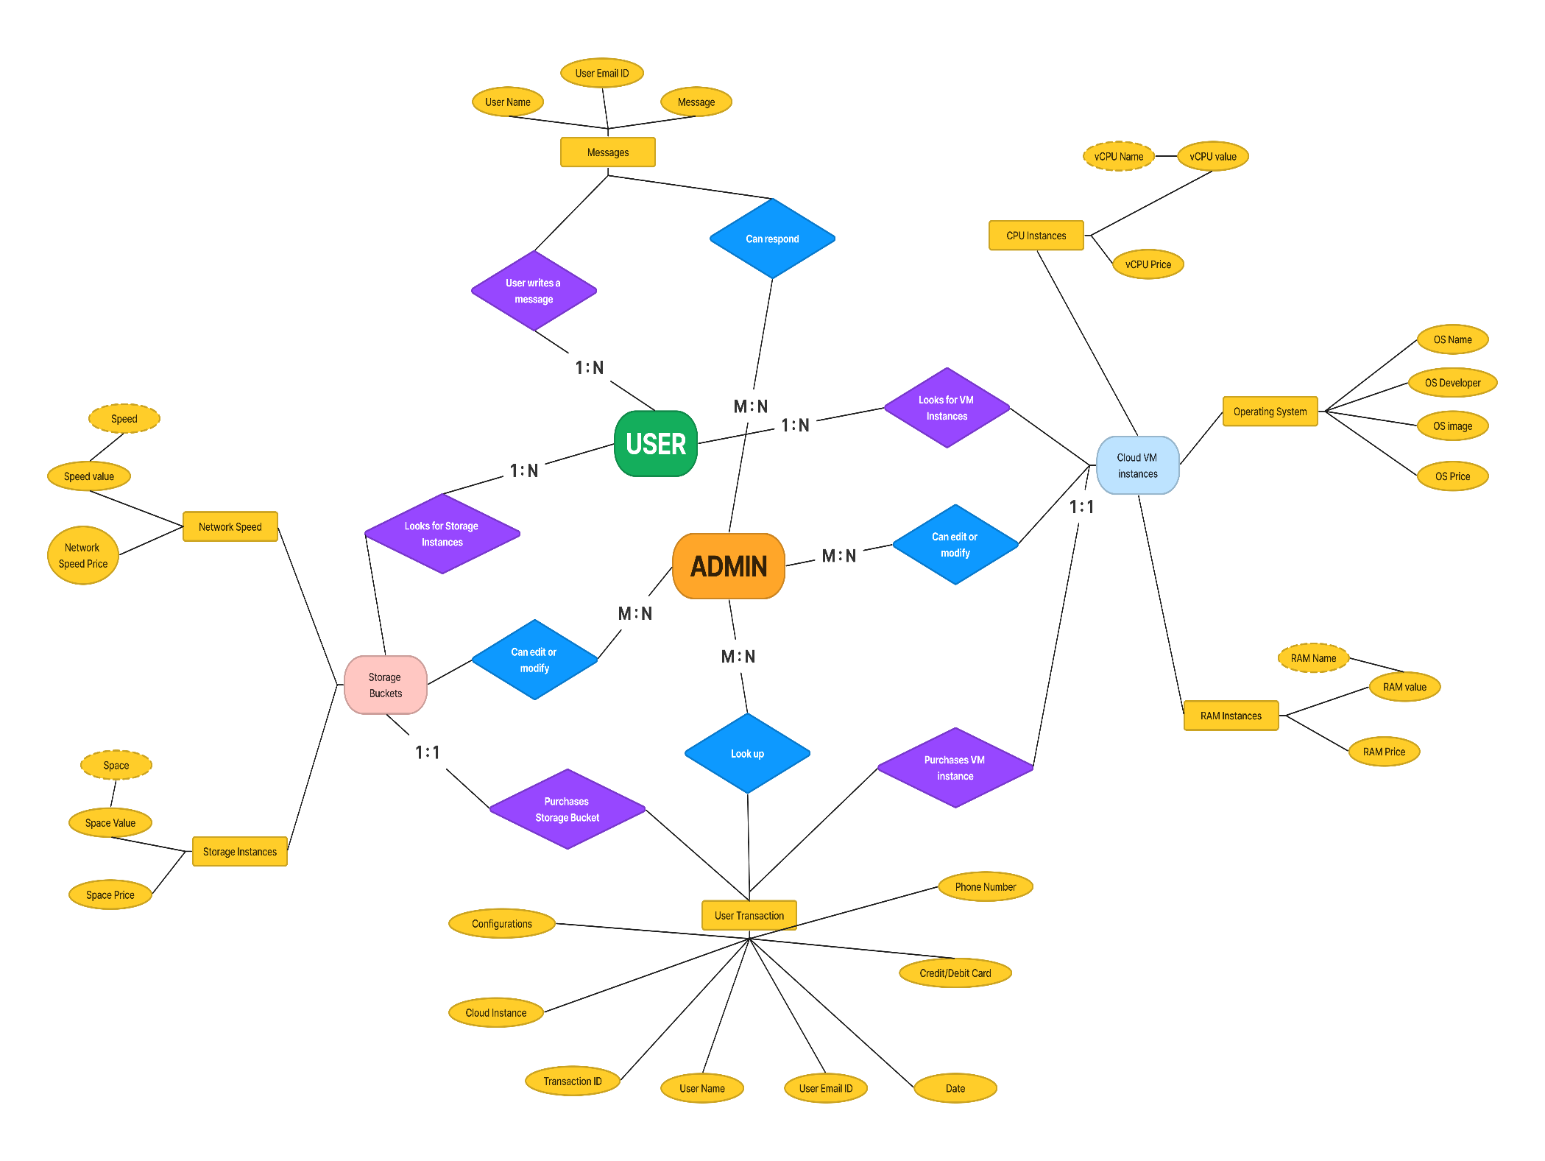*ER Diagram:*